**Hadoop Installation:**

Hadoop is written in JAVA. When you are using Hadoop, you need JDK installed on your machine. Prerequisites to install Hadoop on Windows 10 Operating System is Java and the version needed is 8.

**Part 1: Java**

First check if your computer has Java installed on your Windows Operating System or not by using the command prompt (in administrator mode of course) and entering the command “java -version”

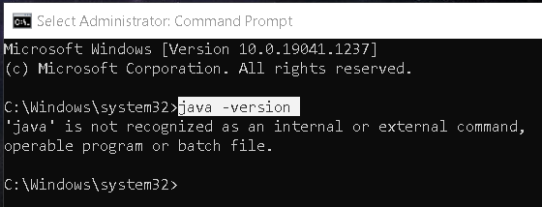

If ‘java’ is not recognized as an internal or external command then you will need to get JDK from the Oracle website which is available for free.

You can choose any 1 from the link: <https://www.oracle.com/java/technologies/downloads/#java8-windows>

Or you can search for Oracle Java SE Development Kit 8u202 on Google and it will provide you the below link that I have used:

<https://www.oracle.com/in/java/technologies/javase/javase8-archive-downloads.html>

Scroll down on the webpage until you find the Windows 64-bit version JDK to download.



After you click on the JDK link it will ask you to agree to the terms and then ask you to sign in using your Oracle account.

Download Button with accept prompt:

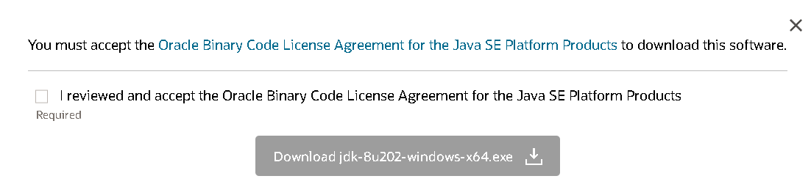

If you don’t have an Oracle account simply choose the create account option.



Once the download is complete you can simply open the file.

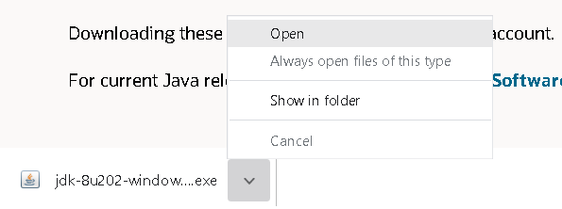

It takes few seconds for the setup window to appear after you have clicked on Open.

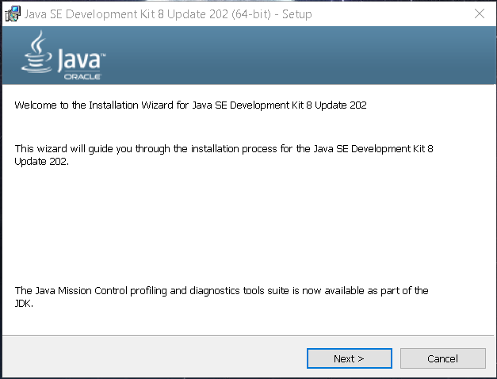

After clicking on the Next button, you will need to ensure that Java gets saved under the C drive directly and not under Program Files.

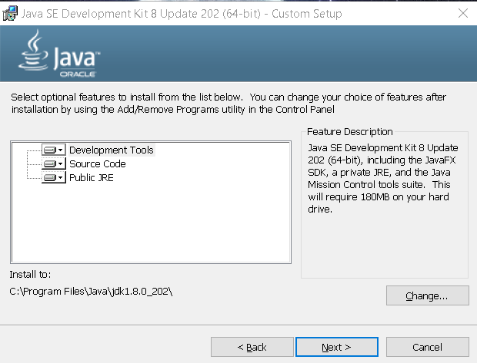

By default, it will take the Program Files option so we need to change the path to C drive before we click on the Next button.

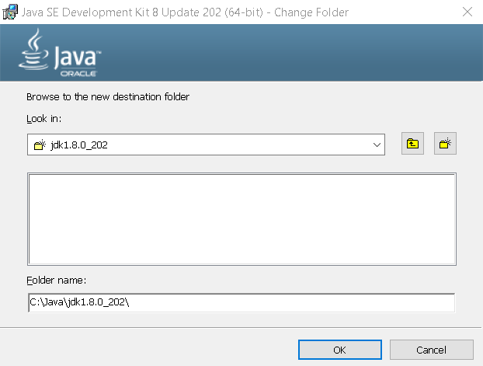

After editing the change folder click on the ok response. Post which you can confirm the new path and click on the Next button. We are making sure that the Java folder gets saved in the C drive directly and not inside Program Files to avoid any future errors.

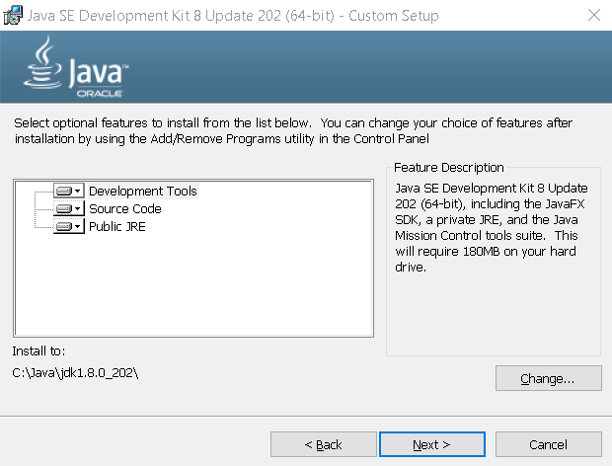

You can see a change in license terms pop up window which needs a simple OK button click.

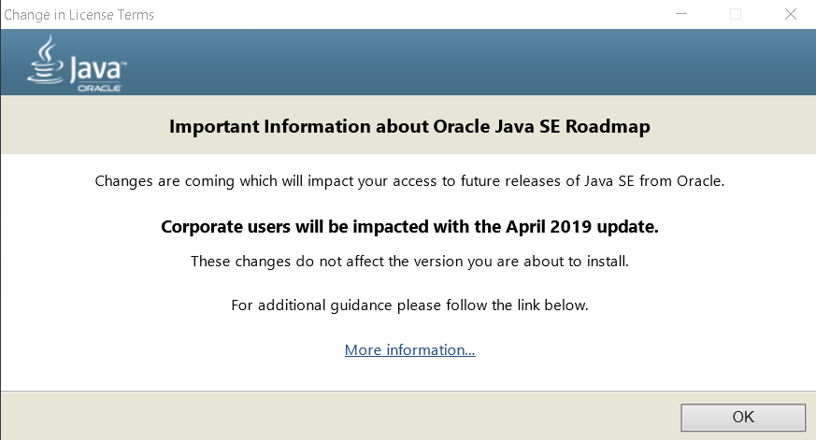

Choose your destination folder and click on the next button.

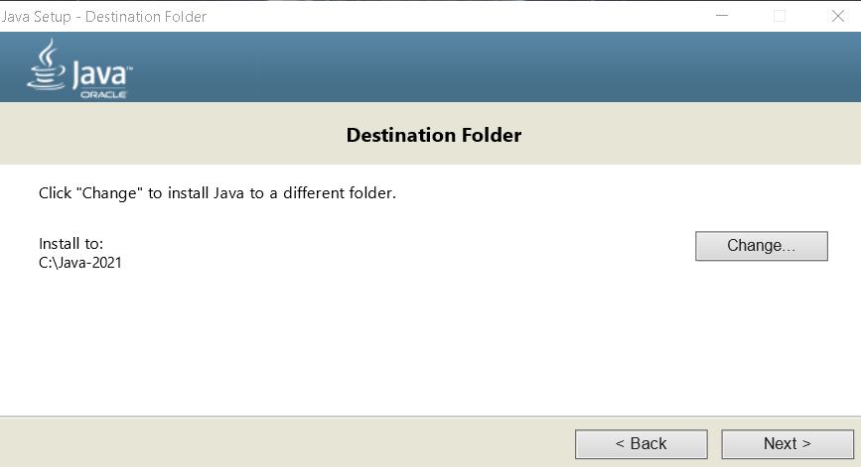

The setup gets initiated and shows the progress bar for it.

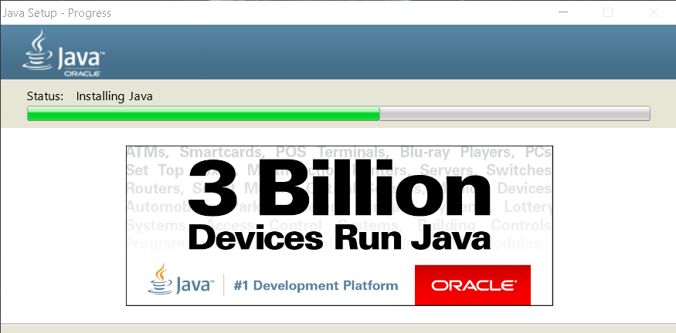

In the installation gets completed in seconds and provides us with the below prompt.

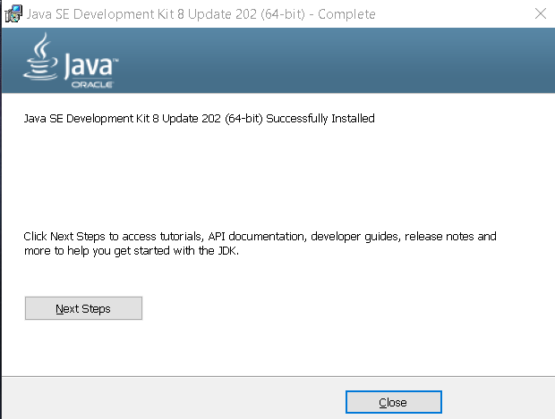

Then we need to go to out File Explorer and locate the Java folder in our C drive.

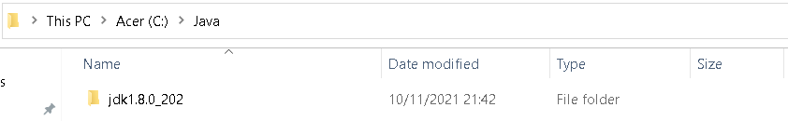

Here we will need to create a new folder named “jre1.8.0_202” just below the “jdk1.8.0_202” folder.

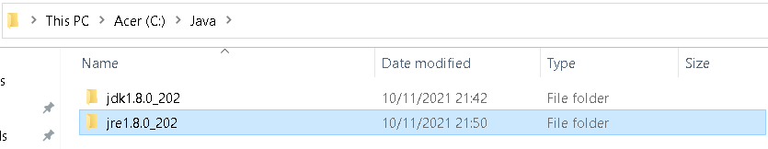

Then you will need to open System Properties by Right Clicking on This PC > Properties > System Protection > Advanced (tab) > Environment Variables

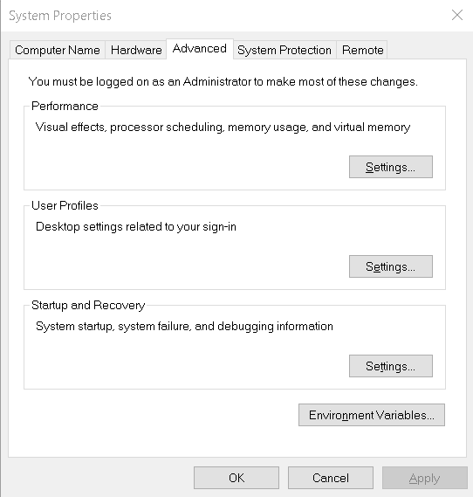

After clicking on the Environment Variables option, we will need create a new User Variable (Beware do not touch the System Variables)

Type in the exact name and value as shown below.

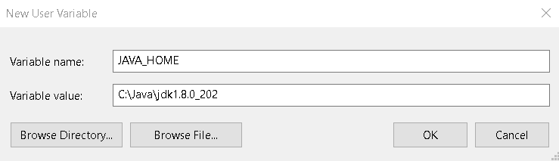

Once you click on “OK” you will get to see the newly created user variable in the list.

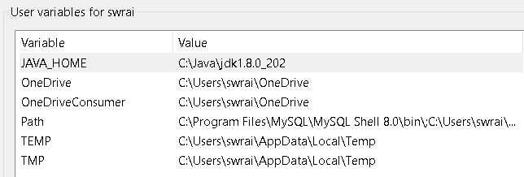

Now we will need to add Path “C:\Java\jdk1.8.0_202\bin” for both user variable and system variable section. You can open the Path by simply double clicking on the name to add New.

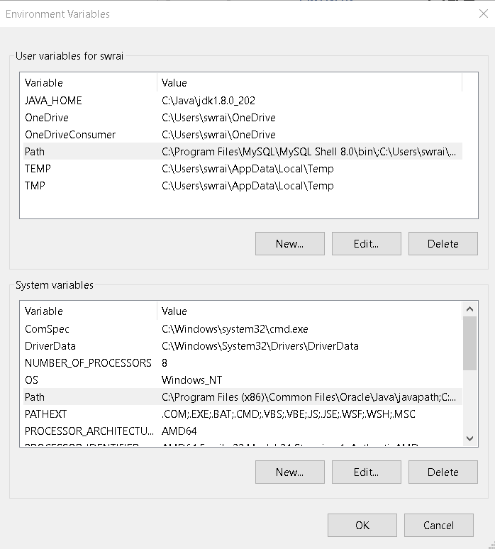

User variable Path:

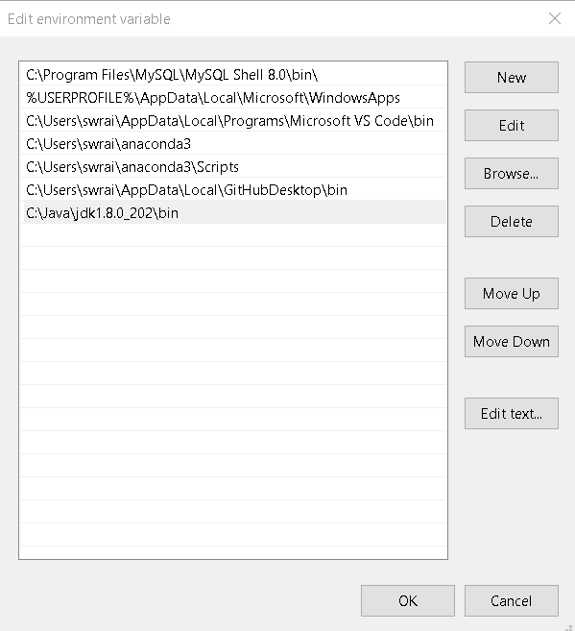

System variable Path:

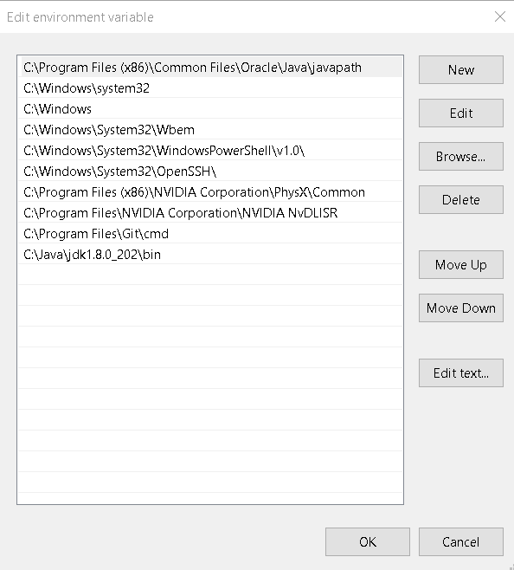

Now simply click o n OK buttons to close the dialogue boxes.

Finally, confirm whether the Java got installed correctly by following the first step and you should be able to see the version this time.

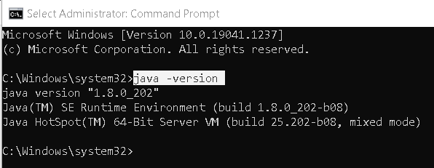

Here 1.8.0_202 reflects the java version that we have successfully installed on the Windows 10 system.

**Part 2: Hadoop**

Now to get Hadoop we will need to download the stable release of it that can be found here <https://hadoop.apache.org/releases.html>

The trick is to identify the most recent release and select the one prior to it since that will be the stable version.

Once you have decided on the version you will need to click on Binary download for it.

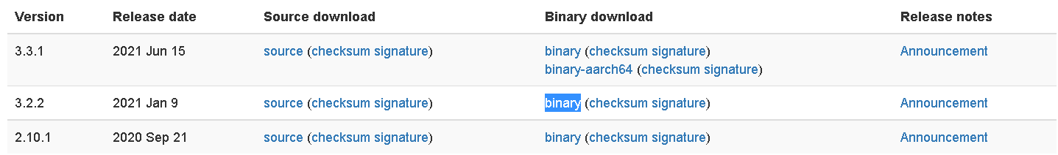

It will then direct you to the mirror download link where you can get the tar.gz file.



Once the download is complete open the folder where the file has been saved.

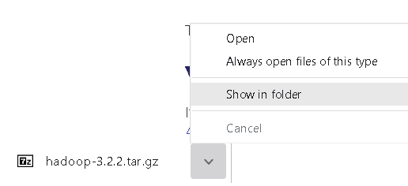

This tar.gz file now needs to be extracted first. If you have WinZip you can do the extraction right away but for someone like me who did not have it available, I chose to use the 7zip for extracting files.

Look for 7-zip on the internet to land on their official webpage <https://www.7-zip.org/download.html>.

Choose the download link exe file and get it installed on your computer.

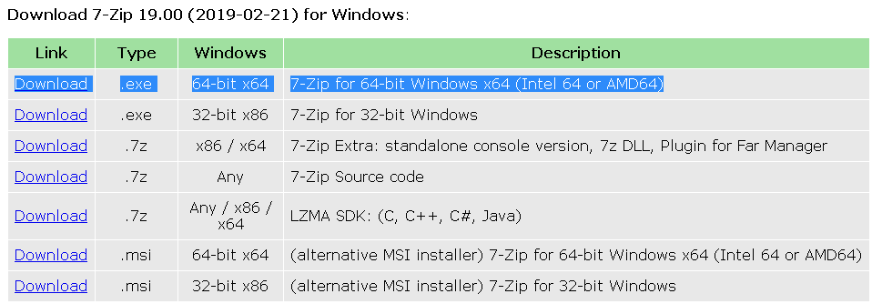

Now you will need to extract the Hadoop tar.gz file using the 7-zipFM option. This is basically for File Manager and provides you with prompts.

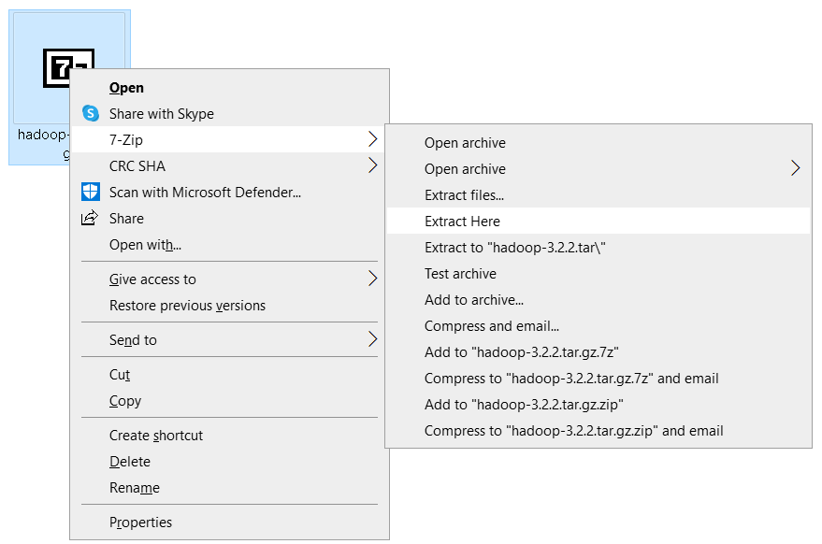

It will then give you a tar file that needs to be extracted again using the same process.

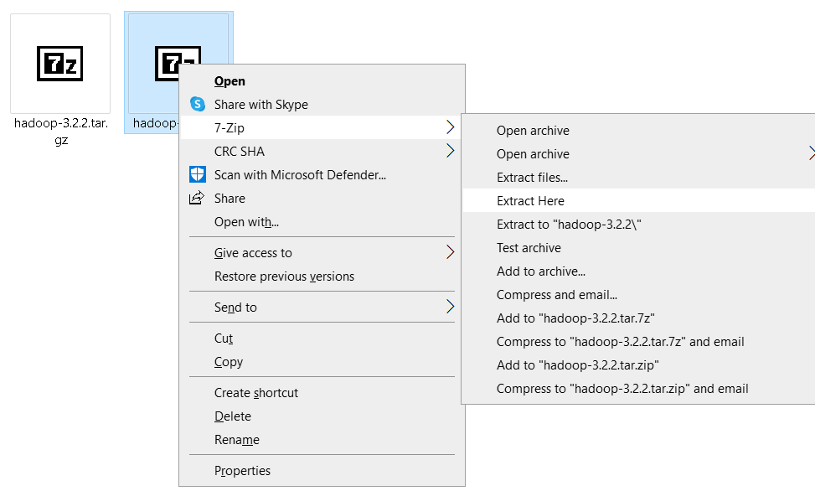

You will then get the Hadoop version named folder and a prompt of 100% extraction completion with 3 errors which can be ignored by clicking on the Close button.

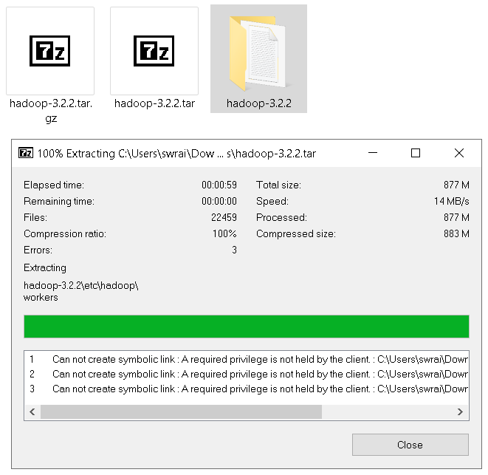

This Hadoop-3.2.2 folder now needs to be moved to your C drive exactly like your Java folder.

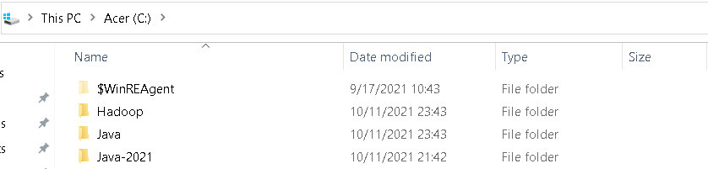

Again, like JAVA_HOME we will need to create environmental variable for HADOOP_HOME too. And easier way to get to it is by typing “environment” in your Windows 10 search box and the choosing the highlighted option “Edit the system environment variables”.

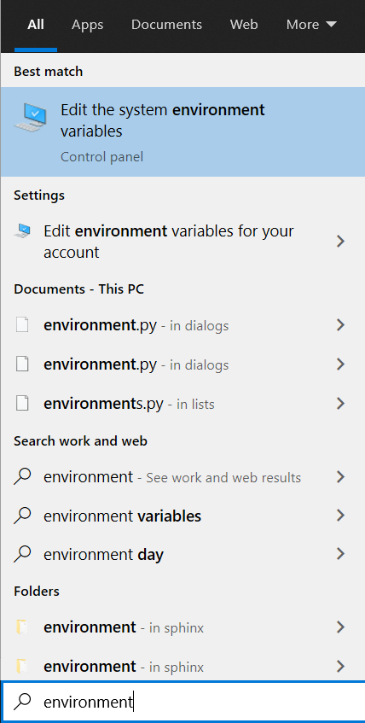

Create a new user variable name HADOOP_HOME with the path as value.

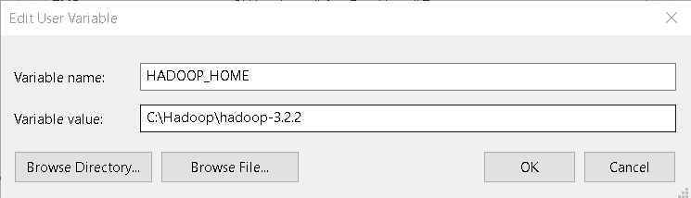

Now we need to set the user variable path with bin and sbin locations.

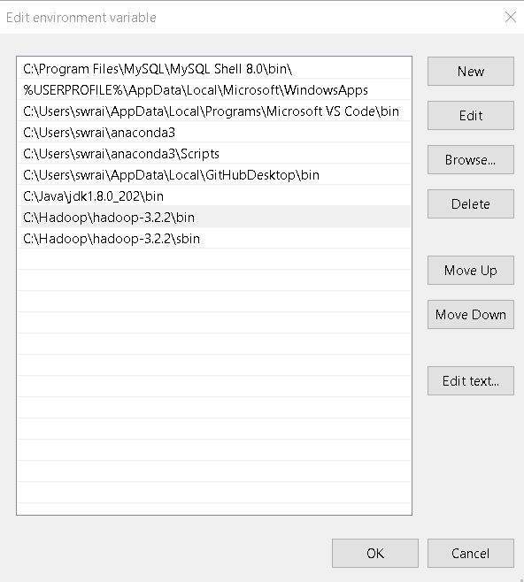

Also need to set the system variable path with the bin and sbin locations.

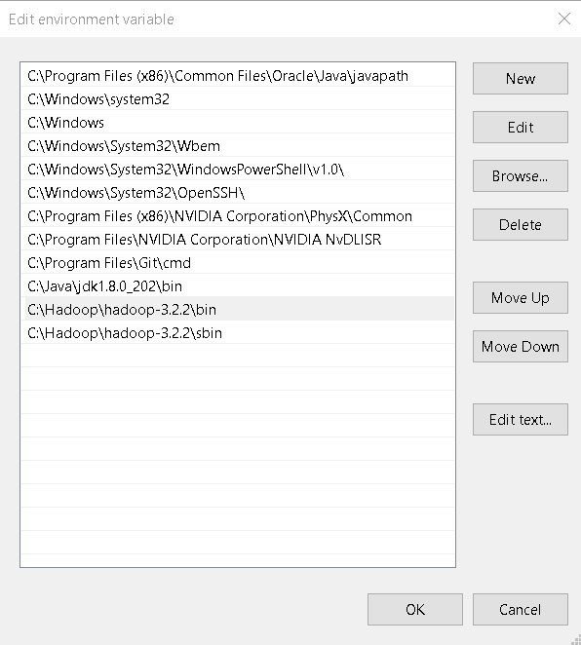

Click on the “OK” buttons to close the System Properties dialogue box.

**Part 3: Configurations for Hadoop**

It is time to edit some configuration files present in the Hadoop “etc” directory. For me the location is C:\Hadoop\hadoop-3.2.2\etc\hadoop

The 4 XML files that we need to edit are core-site, hdfs-site, mapred-site and yarn-site.

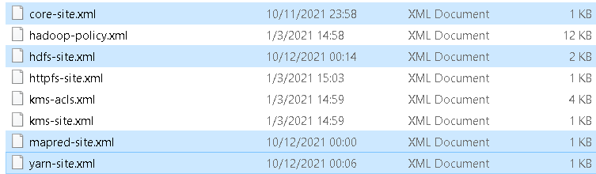

You can open these files in VS Code to edit and make changes. The XML files will have empty configuration location wherein we need to fill our own codes as shown below.

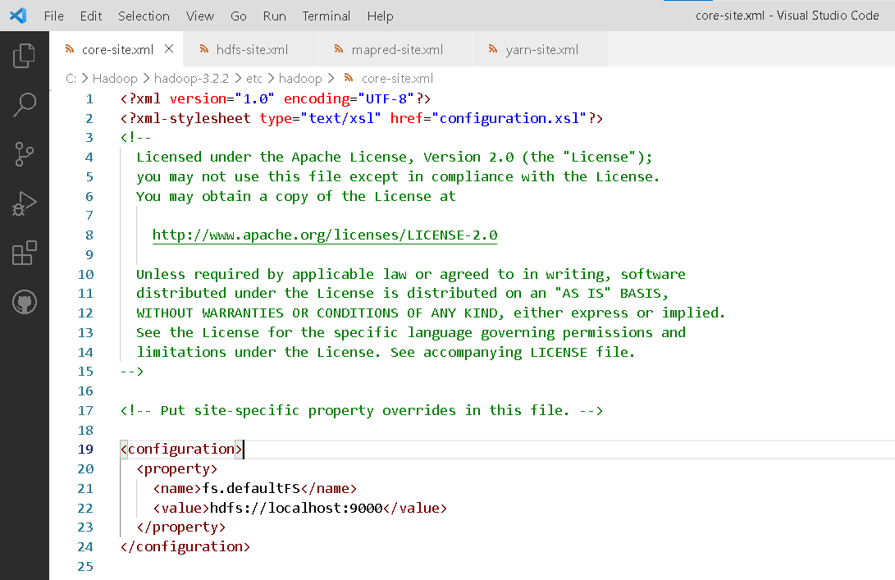

Core-site XML code:

<configuration>

  <property>

    <name>fs.defaultFS</name>

    <value>hdfs://localhost:9000</value>

  </property>

</configuration>

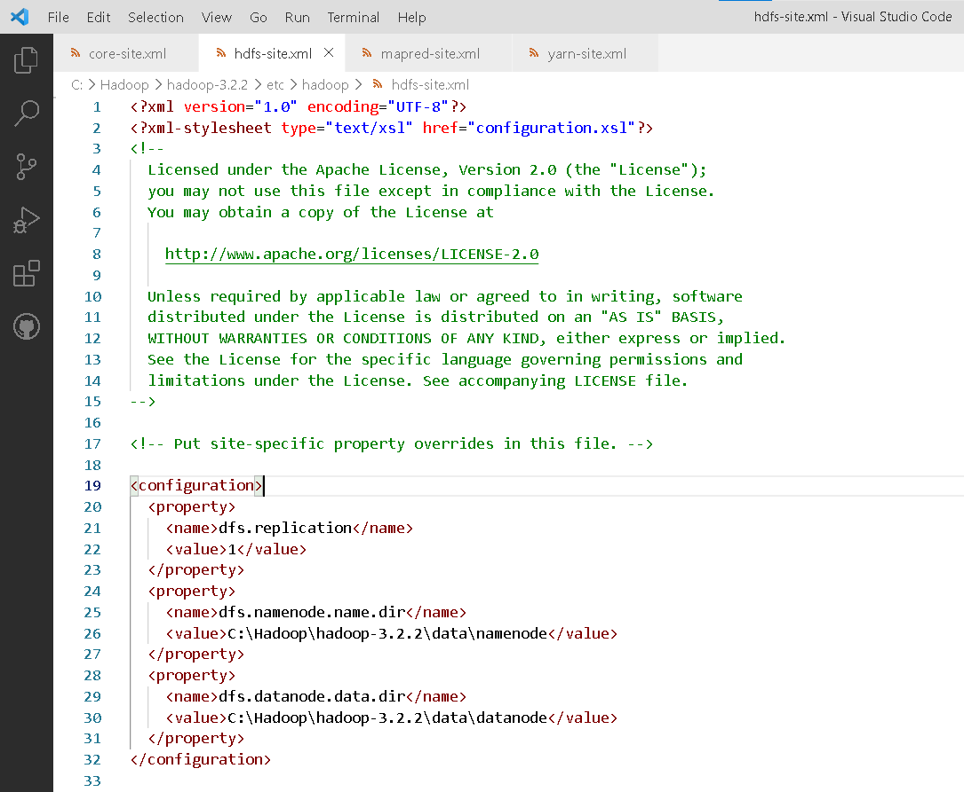

Hdfs-site XML code:

<configuration>

  <property>

    <name>dfs.replication</name>

    <value>1</value>

  </property>

  <property>

    <name>dfs.namenode.name.dir</name>

    <value>C:\Hadoop\hadoop-3.2.2\data\namenode</value>

  </property>

  <property>

    <name>dfs.datanode.data.dir</name>

    <value>C:\Hadoop\hadoop-3.2.2\data\datanode</value>

  </property>

</configuration>

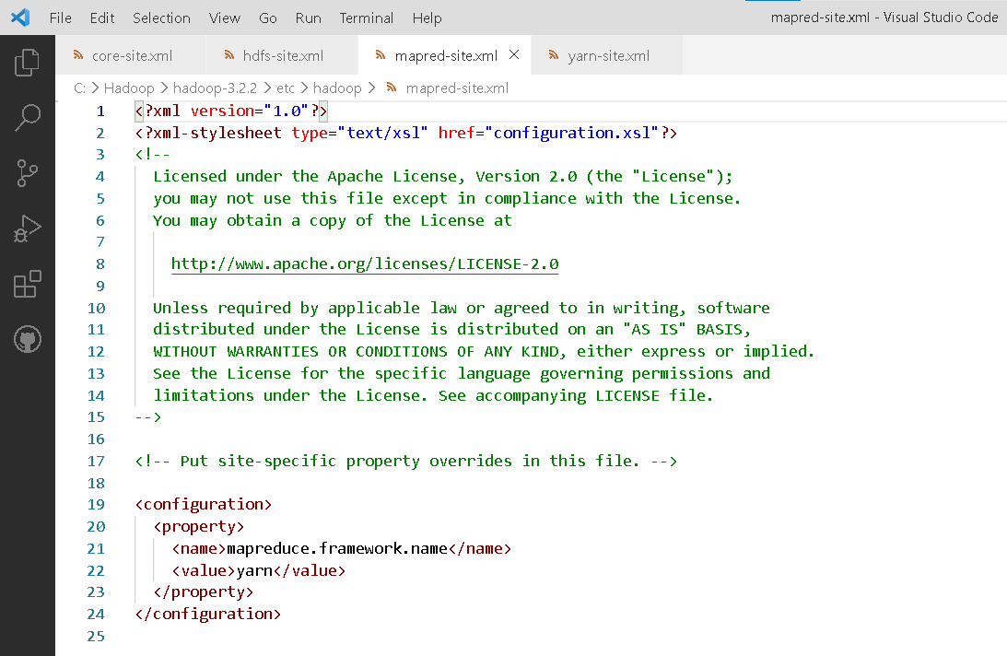

Mapred-site XML code:

<configuration>

  <property>

    <name>mapreduce.framework.name</name>

    <value>yarn</value>

  </property>

</configuration>

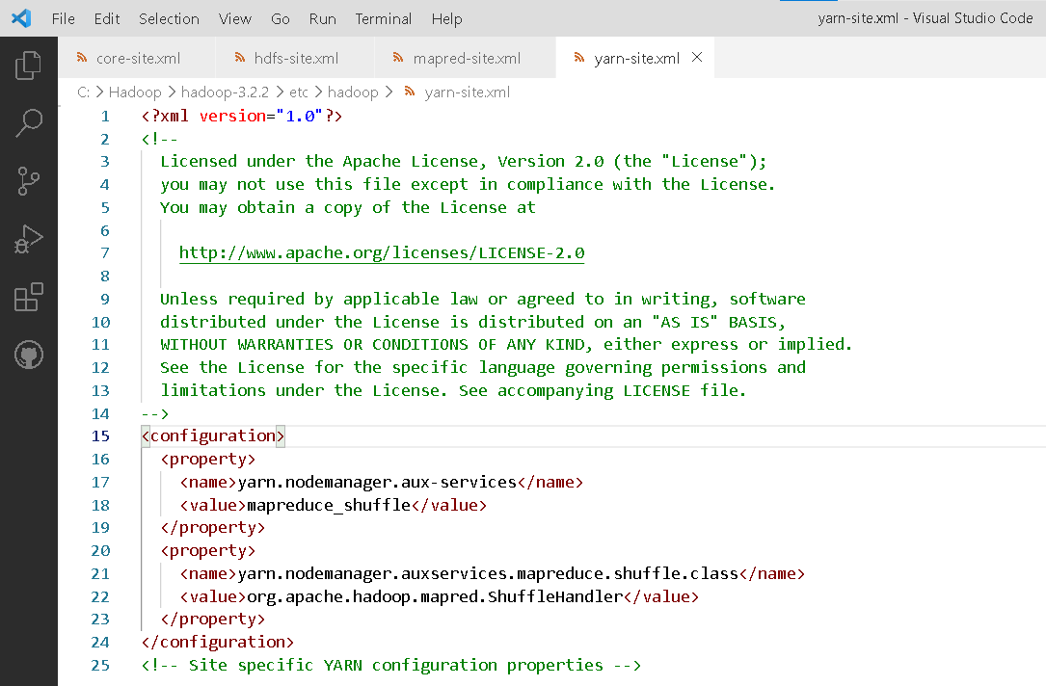

Yarn-site XML code:

<configuration>

  <property>

    <name>yarn.nodemanager.aux-services</name>

    <value>mapreduce_shuffle</value>

  </property>

  <property>

    <name>yarn.nodemanager.auxservices.mapreduce.shuffle.class</name>

    <value>org.apache.hadoop.mapred.ShuffleHandler</value>

  </property>

</configuration>

Last file that needs to be configured is the Hadoop-env.cmd file. You can simply right click and choose the edit option to open the file in a notepad.

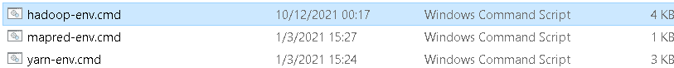

Now look for the line that says JAVA_HOME and remove everything between the % sign along with the % sign and replace it with the Java home location that was set in the environment variable as shown below.



Save all the XML and Notepad files with the configuration changes that were made.

Create a new folder named data under the bin file of your Hadoop directory for me the path is C:\Hadoop\hadoop-3.2.2

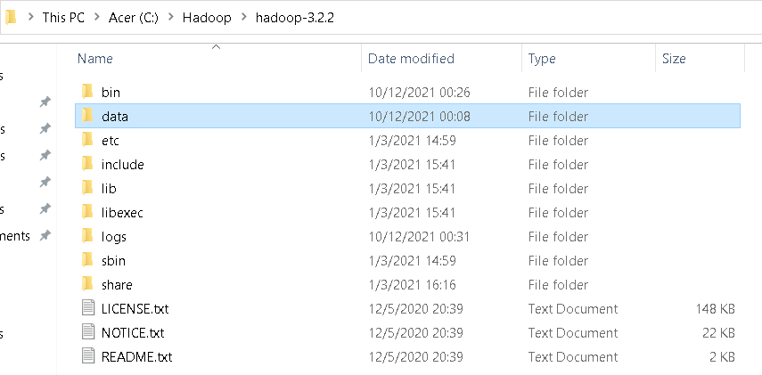

Inside the data folder we will need to create 2 more folders called the datanode and namenode.

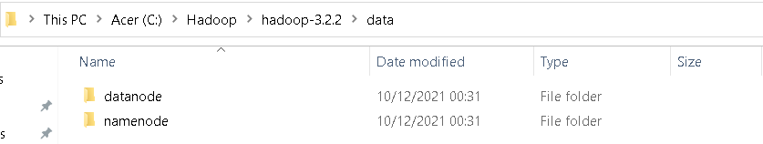

The last step will be to replace the original bin folder in Hadoop with proper configuration files that can be downloaded from <https://github.com/s911415/apache-hadoop-3.1.3-winutils> in zip format.

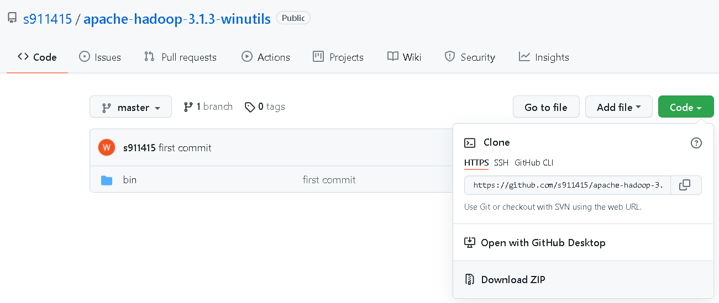

Once the ZIP folder is extracted simply replace this extracted bin with the Hadoop bin folder.

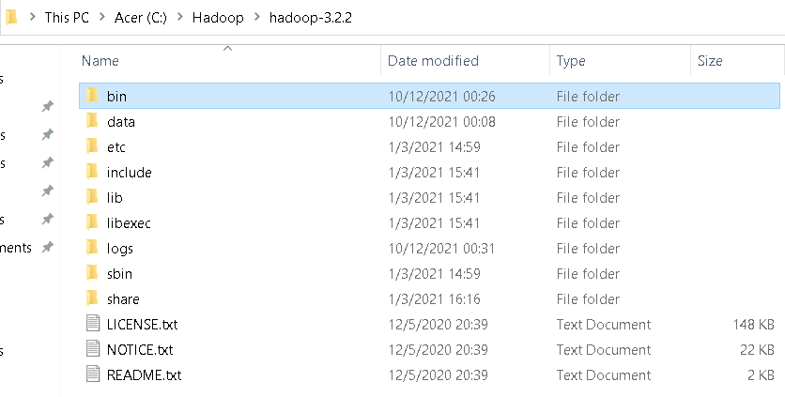

**Part 4: Checking Hadoop Installation**

Here comes the part where we will cross check and confirm that all the above configurations were done correctly. To do so we need to open the command prompt in administrator mode.

1. Hadoop Version

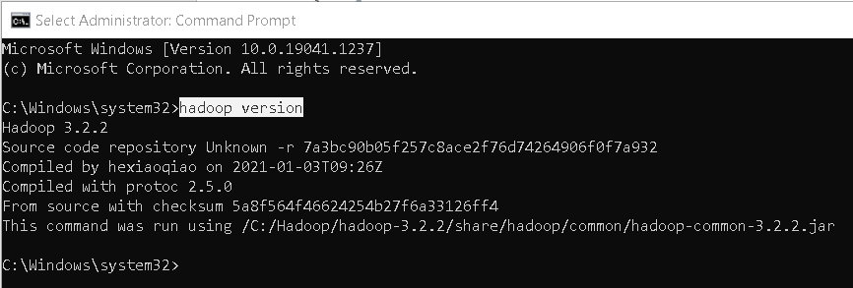

1. Hdfs namenode -format

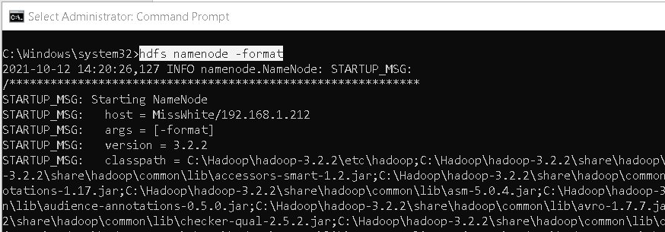

1. Now change the directory to sbin using cd option

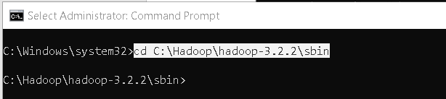

1. We will try to run all the Hadoop Daemons namely namenode, datanode, jobtracker and tasktracker. The command used is “start-all.cmd”

You will notice multiple CMD windows opening automatically and running for namenode, datanode, resourcemanager and nodemanager.

Allow them to keep running while you can bring your main Administrator: Command Prompt at the front.

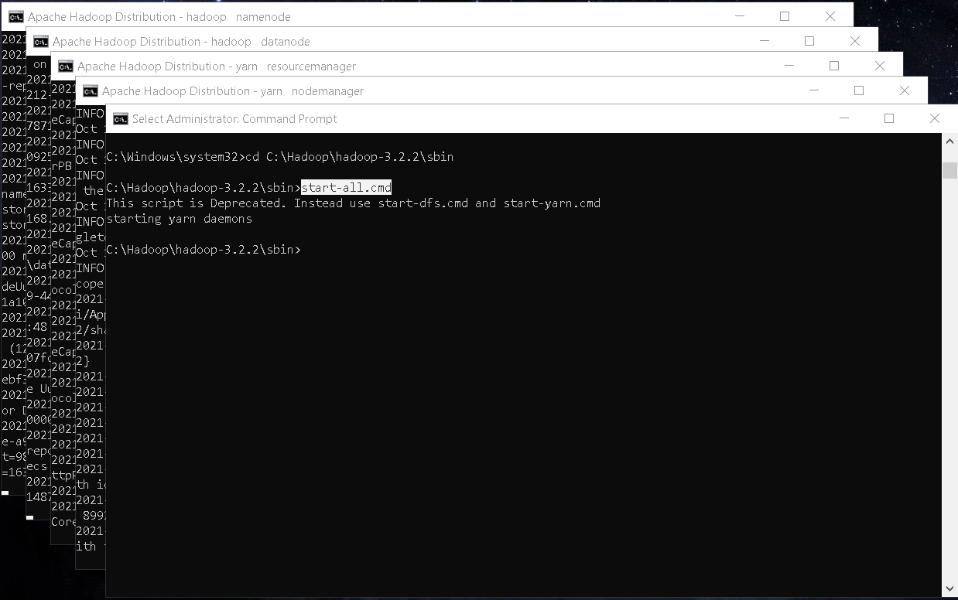

1. JPS stands for Java Virtual Machine Process Status Tool or [JVM Process Status tool]

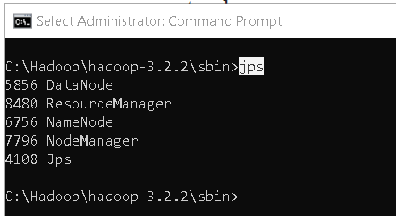

To access information about resource manager current jobs, successful and failed jobs visit this link in your browser - <http://localhost:8088/cluster>